Monday | Tuesday | Wednesday | Thursday | Friday
JULY 2023
SUMMER FUN
See Wilkinson webpage for July Summer Fun Reading List  (books also listed below) |  |  |  | 1  
3  Activity: Build a Fort and play inside. | 4  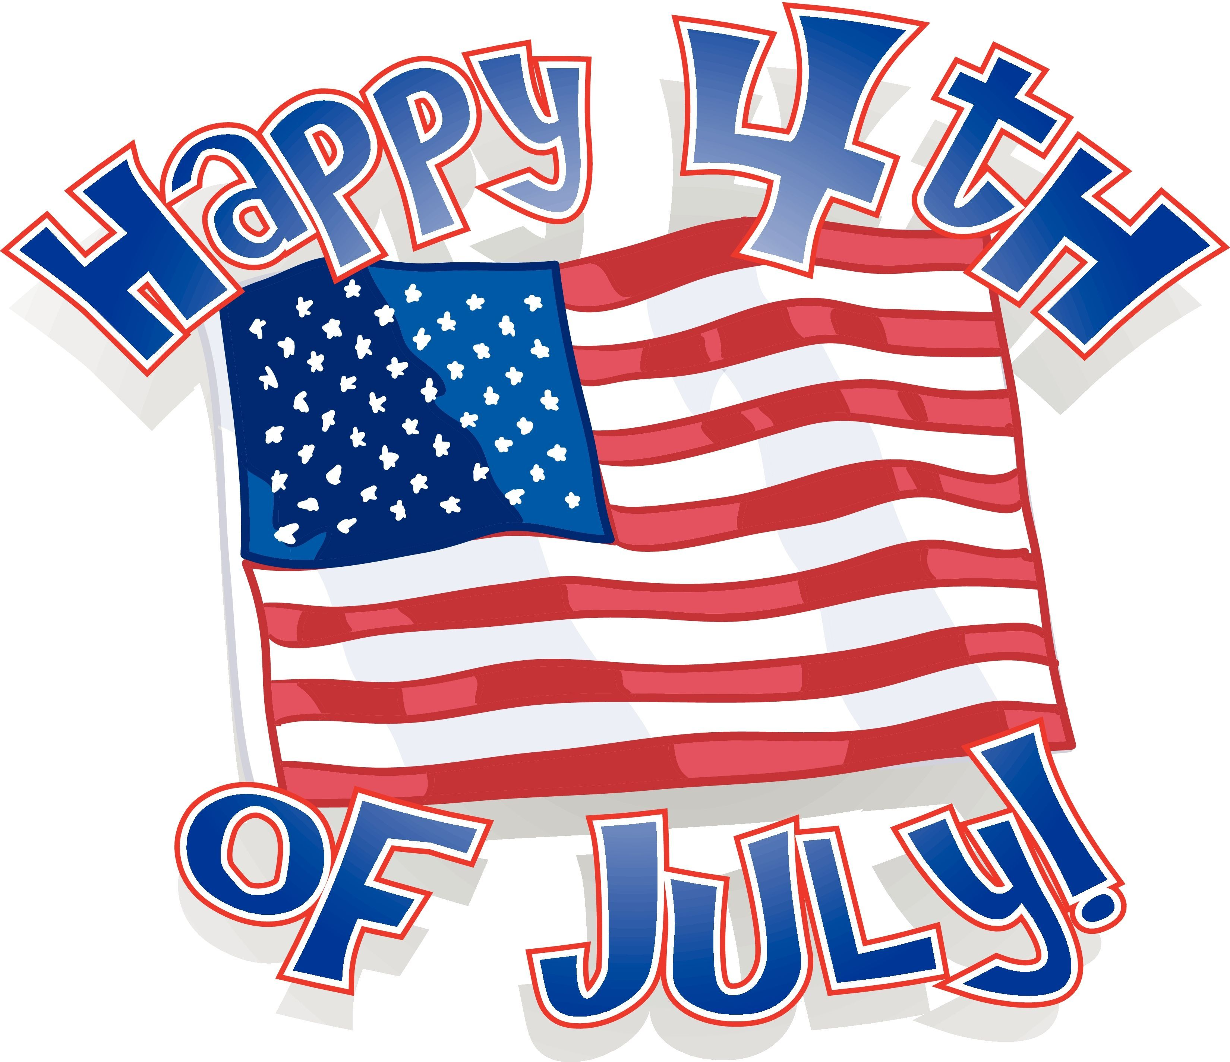 | 5  Activity: Hide a treasure and make clues for someone to find it. | 6  Activity: Use sidewalk chalk draw a picture on the sidewalk count how many days it last. | 7  Free Friday
10  Activity: Make homemade popsicles out of fruit juice or yogurt. | 11  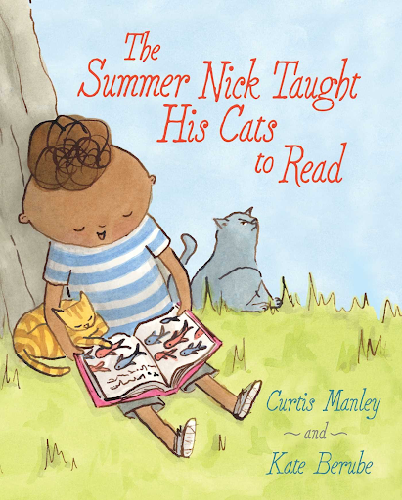 | 12  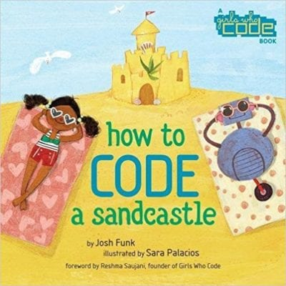  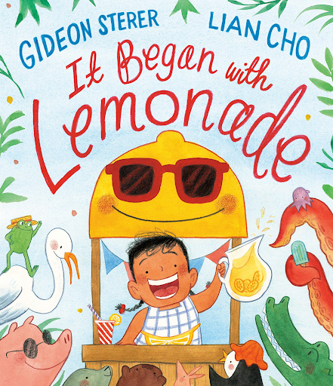 | 13  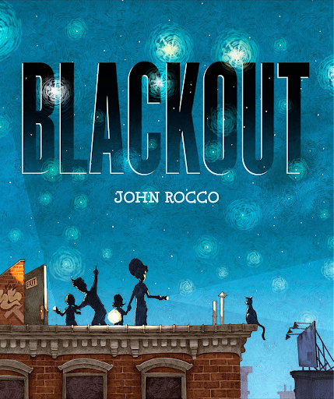 | 14  Free Friday
17  Activity: Have an outdoor water balloon contest. | 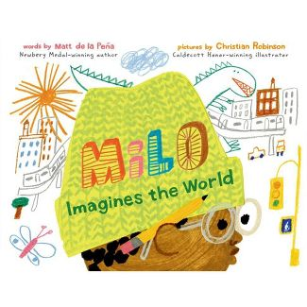  18  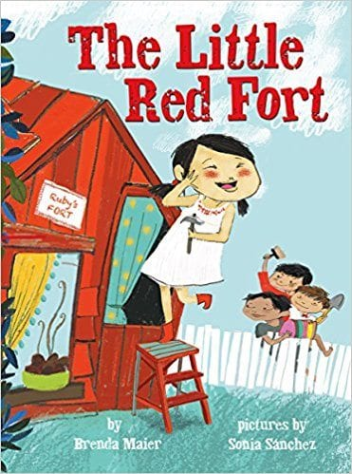 | 19 | 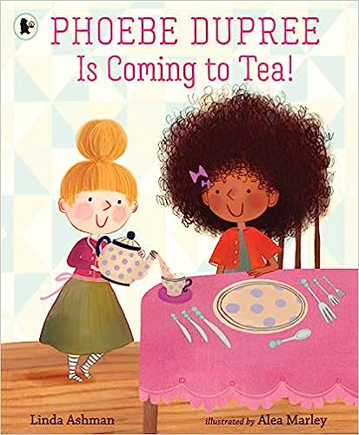  20  Hallway Dance Party  Hallway Dance Party | 21  Free Friday
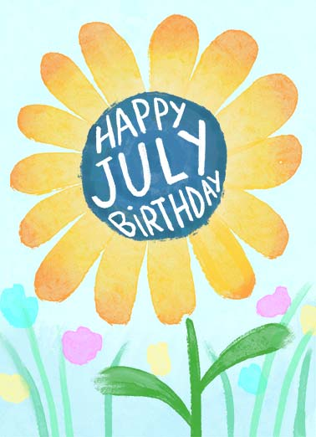  24/31  July  Birthday Postcards | 25 | 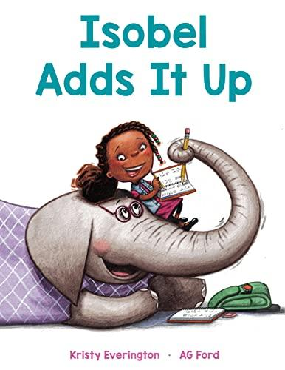  26 | 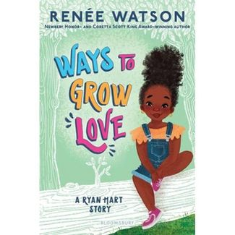  27 | 28  Free Friday

